Implementing INSPIRE: the process towards the harmonization of licenses for public sector geographic information in the Netherlands

B. van Loenen¹, D.W. van Barneveld²
¹Delft University of Technology, Delft, The Netherlands
²Ministry of Spatial Planning, Housing and Environment, The Hague, The Netherlands

This paper focuses on the issue of practical obstacles occurring at the point of use which European Member States are required to address with regard to access and use of INSPIRE data and services. Article 17 of the INSPIRE directive reads literarily: “Each Member State shall adopt measures for the sharing of spatial data sets and services between its public authorities”. Those measures shall enable those public authorities to gain access to spatial data sets and services, and to exchange and use those sets and services, for the purposes of public tasks that may have an impact on the environment. The measures provided for shall preclude any restrictions likely to create practical obstacles, occurring at the point of use, to the sharing of spatial data sets and services.

What is a practical obstacle at the point of use?
The Directive itself provides very little information about what these practical obstacles may be, and how these should be addressed. The Directive limits itself to “Ad hoc negotiations between public authorities every time access is required” which may be overcome by prior agreements between public authorities.
In the Netherlands, we identified three types of possible practical obstacles at the point of use:

● Money
● Time between request and use
● Use restrictions

Research, both in the Netherlands (see Groot et al., 2007) and internationally (see, for example, Micus, 2008), but also statements of representatives of the private sector are clear (e.g., Tanguy de Lestré chairman of Agoria, Association of Belgium IT companies): ”It is not the price that matters, it is transparency in what is available and what conditions apply”. Not only is public sector geographic information (PSGI) difficult to find as it is spread throughout many different government organizations, each agency also applies different license conditions. As a result, it is time-consuming to find and obtain the needed information, it is unclear whether it is okay to combine different datasets and/or services in a new product, licenses are difficult to understand directly and as a consequence datasets and/ or services are not being used, business processes are delayed and the transaction costs (the cost to find a dataset, assess its fitness-for-use, acquire the dataset and to make it fit for use) are much higher than necessary. A transparent application of harmonized use restrictions can shorten the time between a request and use significantly. This holds true especially if harmonization results in computer readable licenses allowing automated transactions.
Research showed (see Welle Donker and Van Loenen, 2006) that the use conditions for PSGI are very similar for different PSGI in the Netherlands. They introduced a single framework that accommodates most of the existing licensing conditions (Welle Donker et al. forthcoming). Primary purpose of the framework was to promote the transparency of the licenses and consistency between the licenses used in the public GI sector in the Netherlands. The framework was not designed to enforce a certain access policy and/or business model. Therefore it should only result in the harmonization of the existing licensing situation, not change the existing situation in any other way.
Harmonization of PSGI licenses should result in transparent and consistent licenses for PSGI. In this way one of the practical obstacles at the point of use for INSPIRE was addressed.

Geo shared
In 2006 a preliminary harmonization model was presented at the EC GI/GIS conference in Innsbruck, Austria (see Welle Donker and Van Loenen, 2006). This model harmonizes the structure of the licenses, their terminology and the content of the licenses. It heavily builds on the Creative Commons concept, including a symbol representing a use condition, a layman's text and a legal text. However, discussion with the Creative Commons representatives in the Netherlands clarified that the Creative Commons model was not to be applied to datasets where a fee needs to be paid. Since several datasets in the Netherlands are fee-based, an alternative model was needed to be all-inclusive. This model we developed is the geo-shared framework. The first iteration of this model dates from 2007. This model was further developed in the context of the INSPIRE implementation in the Netherlands.
Since the expectation was to have most discussion with the stakeholders on the content of the use conditions, and not so much on the structure of the license, or the terminology used for a specific restrictions, we focused on the use conditions in our discussions with the INSPIRE stakeholders. The public GI sector was asked about the first version of geo-shared after which the model was developed further. Two workshops, interviews with individual organizations, and several feedback moments resulted in the model as shown in figure 1.

Public Domain | Work is in the public domain: no use restrictions apply
 | Work can be used and reused if name of copyright holder and the date of the creation of the Work is mentioned on the Work.
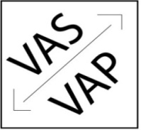 | Derivative works only if. The Work can only be part of a Derivative works if the Work is not selectable from the Derivative Work.
= | Only identical copies of the Work may be distributed to others.
 | Time limitation. The license is valid for a limited period.
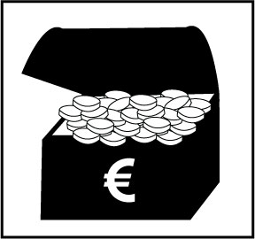 | Fee is required. Use of the dataset requires a monetary payment.
 | Only non-commercial use. The dataset can only be used for non-commercial purposes.
+ | Other restrictions. Other restriction then the above apply (e.g., privacy).
Figure 1: The Framework of Geo-shared 2.0

This framework applied to the individual organizations results in the overview in figure 2. Figure 2 shows that the Geo shared framework can be applied to data policies currently present for PSGI. The plus icons (for the Kadaster and Ministry of Agriculture, nature and food quality) are related to privacy restrictions.

Organization | Use of Geo shared framework
Kadaster |   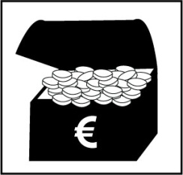  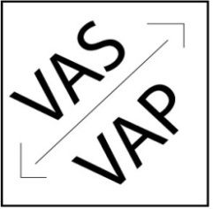  +  =
Royal Met Office (KNMI)  Municipalities  Hydrological Service  Alterra | =
Statistical Office (CBS)
Min. Public Works (RWS)
Geological Service (TNO)
Min. Agriculture (LNV) | +  =
Provinces | Public domain
Water authorities | Public domain  Or
Figure 2: The Framework of Geo Shared 2.0 applied to public sector organization in the Netherlands

Future steps

Although the current model is assessed to fit the current licensing models, but then in a harmonized way, does not impact on the business models of the public sector organizations, and was developed in close cooperation with the GI-community, its implementation may still face several roadblocks.

Bringing the framework towards acceptance and implementation in the individual organizations
Although the framework is applicable to the situation in all organizations with INSPIRE data, these organizations do have to change their current licensing models.

Automatic generation of a license
After acceptance and implementation, Geo shared may result in an automatic license developing tool where answers to several standard questions result in a geo-shared license. Example questions may be: Does a user have to give attribution to the source of this dataset? This process is similar to what Creative Commons already has developed at www.creativecommons.org.
Depending on the answers to these questions a license will be created, and linked to the dataset or service. This linking will come with an icon representing the use conditions (see figure 3).
Putting the use conditions in the metadata files will allow for searching for INSPIRE data based on use conditions. Searching for public domain data will then be possible.

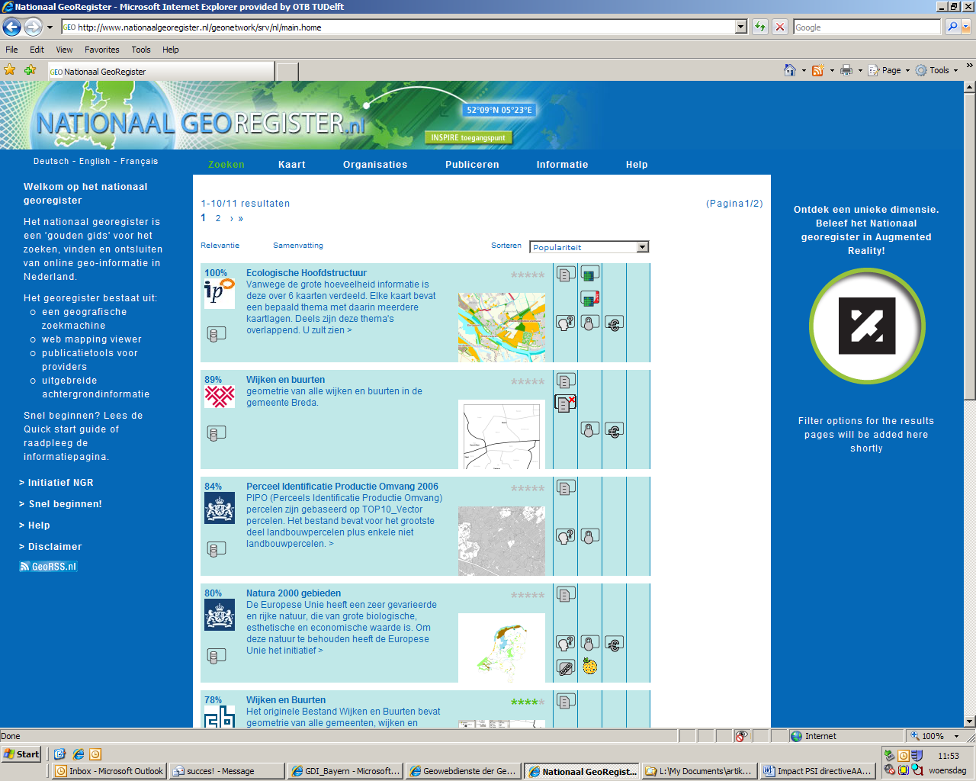

Figure 3: Searching for data with a certain use restriction in the Dutch INSPIRE portal?

Conclusion
INSPIRE stimulates Member States to remove practical barriers occurring at the point of use. One of these practical barriers is the lack transparent and consistent licenses for INSPIRE data and services. The development of the Geo-shared licensing framework is aimed at providing the required transparency and consistency. The framework was positively received by the stakeholders in the Netherlands. Now it needs to be implemented to ensure that users of INSPIRE data and services can readily access and use these. We are positive about the successful implementation and expect that it might be worthwhile to consider a similar framework in an European context. Only then will INSPIRE reach its full potential.

Literature
Groot N, Bregt A, Crompvoets J, Pluijmers Y, 2007, "Toegankelijkheid publieke geodata vooral gehinderd door juridische barrières" [Accessibility of public sector geodata mostly hampered by legal barriers] VI Matrix 116 jrg.15 nr.8 6-8

Micus Gmbh, 2008. Assessment of the Re-use of Public Sector Information (PSI) in the Geographical information, Meteorological Information and Legal Information Sectors. Study commissioned by EC in 2007.

Welle Donker, F. and B. van Loenen, 2006. Transparency of accessibility to government-owned geo-information, Proceedings of the 12th EC-GI&GIS Workshop, Innsbruck, Austria, 21-23 June 2006, pp. 89-96 (ISBN 92-79-02083-8).

Welle Donker, F., van Loenen, B., & Zevenbergen, J., forthcoming. Geo Shared licences: a base for better access to public sector geoinformation for value-added resellers in Europe. Environment and Planning B: Planning and Design, advance online publication.

